Keeping of Animals Bylaw – Early engagement
Introduction
We are seeking your feedback on animal nuisance issues to help shape our new Keeping of Animals Bylaw. This Bylaw outlines rules for the keeping of animals within the Waikato district and helps to ensure we can all live alongside each other in a safe and healthy way.
Description
Here at Council, we love animals! Animals are beloved members of our families and play a vital role in various businesses. Animals also provide the community with the opportunity to produce their own food. We know how much the Waikato district community loves and cares for their animals.
But sometimes animals can be a real nuisance. Roosters and chickens can be loud, and pigs can be smelly. The noise and smell can become an issue for neighbours in urban areas, especially where properties are close together. Bees can poop on houses and cars, and sting. Animals can also wander unattended through our towns or rural areas. This can create safety issues for drivers and cause harm to other people and/or their property.
We want to hear your ideas for the proposed Keeping of Animals Bylaw. This Bylaw includes rules for managing animal nuisance issues in the Waikato district. It can also include where and how animals can be kept, specifically for pigs, poultry, bees, and horses.
This is your chance to have your say early before we kick off consultation on the formal proposal and Bylaw later in 2024.
It’s important to note that this Bylaw does not apply to dogs. Our rules for dogs are included in the Dog Control Bylaw and Dog Control Policy, which can be found on our website.
Below are examples showing how rules were in place throughout the Waikato district in the previous Bylaw.
This table shows different rules for our urban, lifestyle or rural areas. Rules in urban areas tend to be the most limiting, as the proximity of houses mean animals can cause more nuisance. For this reason, there are fewer rules in our lifestyle and rural areas.

Example rules from the Keeping of Animals Bylaw 2015
Animal | Urban | Lifestyle | Rural
All animals | General nuisance rules apply across urban, lifestyle and rural for all animals
 | No pigs. | Pigs allowed.  Pigstys must not be within 20m of dwellings or 30m from adjoining boundaries. | Pigs allowed.  Pigstys must not be within 20m of dwellings or 30m from adjoining boundaries.
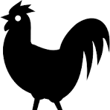 | No roosters. | No roosters in the ‘Country Living Zone’ from the Operative District Plan | Roosters allowed.
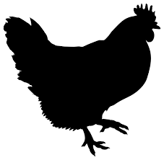  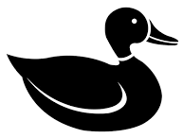  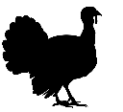  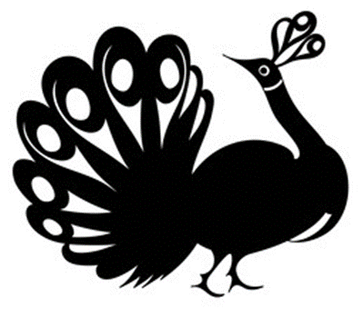  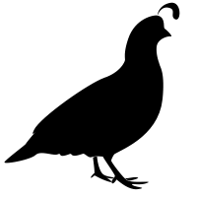  Poultry includes chicken, ducks, geese, pigeons, turkeys, pheasants, quail and peacocks. | Limits on poultry numbers.  Enclosed housing for poultry is required. | Poultry allowed. | Poultry allowed.
 | Poultry houses must be 10m away from buildings and 3m away from property boundaries. | Poultry houses must be 10m away from buildings and 3m away from property boundaries. | Poultry houses must be 10m away from buildings and 3m away from property boundaries.
 | Limits on beehives: | Limits on beehives in ‘Country Living Zone’ or ‘Rural Residential Zone’ from the Operative District Plan | Unlimited number of beehives.
 | Property area:  500-2000 square metres: 2 beehives  2001-4000 square metres: 4 beehives  4001 square metres +: 6 beehives | Property area:  500-2000 square metres: 2 beehives  2001-4000 square metres: 4 beehives  4001 square metres +: 6 beehives
 | Beehives must be setback 3m (if there is a solid fence) or 5m (if there is no solid fence) from property boundary. | Beehives must be setback 12m from the property boundary. | Beehives must be setback 25m from the property boundary.
 | Horses allowed, provided horses are kept by a registered breeder or in a stable. | Horses allowed. | Horses allowed.
The following rules apply to feral or stray animals (including cats) across the district:
- No one should offer support or shelter to a feral or stray cat if the cat becomes a nuisance to others.
- If an animal causing a nuisance is identified as feral or stray, the property owner must take appropriate measures.

Timeline

Early Engagement
We are now looking for feedback - we’d love to hear your ideas for the proposed Bylaw! Please explore this page and share your thoughts.

Policy drafting
We will collate your feedback to inform our draft Bylaw.

Formal consultation
Once we’ve put together our proposal, you’ll have an opportunity to have your say on the proposed Bylaw. This will happen later in 2024.

Hearings and deliberations
Council will hear your thoughts in person at a Council meeting and will decide on the final changes to the Bylaw.

Bylaw adoption
A round of a-paws. We did it!
Frequently asked questions
- What is the Keeping of Animals Bylaw?
The Keeping of Animals Bylaw is a regulatory framework established by Council to govern the keeping of animals within our community. It sets out guidelines, rules, and requirements regarding animal ownership and responsible animal management to protect the public from nuisance and maintain public health and safety.

- Why do we need a Keeping of Animals Bylaw?
Council wants this Bylaw to effectively manage animal nuisance problems in the district. A bylaw can include rules around how to keep animals to minimise the potential nuisance to other community members.

It is also a tool that Council uses to engage with the community when complaints are received from across the district about animal nuisance. A bylaw supports Council’s monitoring staff to promote responsible animal ownership.

- What is the most significant animal nuisance issue in the Waikato district?
Our team at Council have taken a close look at animal nuisance complaints data from 1 July 2018 to 30 June 2023. This allowed us to understand the frequency and type of animal related complaints received. Over the past five years, Council has received 363 complaints relating to animals (excluding dogs).

Roosters top the list as the animal that received the highest number of complaints, followed by chickens. Members of the community most frequently complain to Council about animal noise. The two graphs below give more detail about complaints.

- Why is Council making a new Keeping of Animals Bylaw now?
Council has previously had a Keeping of Animals Bylaw and consulted with the community on changes to a Keeping of Animal Bylaw over December 2020 and January 2021. The reviewed Bylaw was later adopted by Council in May 2021.

However, Council has since become aware that the Keeping of Animals Bylaw 2015 (adopted in 2021) was not reviewed within the required legislative timeframe. Council is currently relying on education to improve awareness until a new Bylaw is adopted.

Council is fully committed to rectifying the situation transparently. A new Keeping of Animals Bylaw is proposed to ensure Council can manage animal issues effectively.

- How is the Bylaw enforced?
A Keeping of Animals Bylaw is enforced by Council’s monitoring officers. Council takes the approach of engaging, educating and then enforcement (if necessary). Council can enforce breaches of a Bylaw through a fine of up to $20,000.

- Will the Bylaw be enforced retrospectively?
For existing animals, Council will not retrospectively enforce bylaw rules that specify designated areas for keeping certain types of animals. However, the general nuisance rules in the Bylaw remain applicable. Any nuisance caused by noise, odour, or other issues associated with the animals is considered a current issue and could result in enforcement under the new bylaw.

- What will you do with my feedback?
Your feedback will be analysed and provided to Council and will be used to shape the next iteration of the Bylaw. Council will formally consult on the proposed Bylaw later in 2024.

- Can I see the previous Bylaw?
Yes, we have attached a copy of the previous Keeping of Animals 2015 Bylaw for your reference.

Feel free to read through the previous Bylaw to understand the types of things we have covered historically.
Online survey
- First name
- Last name
- Organisation (if applicable)
- Postal address
- Email
- Address
- Have you, or your organisation, experienced animal (excluding dogs) nuisance in the Waikato district?
- Yes
- No
- If yes, please share details about the type of nuisance you experienced – such as the type of animals that caused the nuisance and nuisance type, such as noise, roaming and odours. Your insight will help us better understand and address these issues effectively in a proposed bylaw.
……………………………………………………………………………………………………
……………………………………………………………………………………………………
- Do you believe roosters should be allowed to be kept in lifestyle areas in the Waikato district?
Lifestyle areas are defined as properties with a land area of 2,500 square metres to 15,000 square metres.
- Yes
- No
- Unsure
- Please tell us why:
……………………………………………………………………………………………………
……………………………………………………………………………………………………
……………………………………………………………………………………………………
- We are considering using property size to define the terms “urban”, “lifestyle” and “rural”, for the purposes of this Bylaw.
Urban: Up and including 2,500 square metres.
Lifestyle: 2,500 square metres to 15,000 square metres.
Rural: 15,001 square metres or larger.
Do you support this approach?
- Please tell us why:
……………………………………………………………………………………………………
……………………………………………………………………………………………………
……………………………………………………………………………………………………
- What type of bird/s do you believe should be included in the definition of poultry, and why?
……………………………………………………………………………………………………
……………………………………………………………………………………………………
- What is the preferred limit for the number of poultry (including chickens) you would be comfortable allowing in our urban areas?

Please select from the following options.
Urban areas | Number of poultry
Properties less than 550m2 | 0 | 1-3 | 4-6 | 7-9 | 10-12 | 13+
Properties more than 550m2 | 0 | 1-3 | 4-6 | 7-9 | 10-12 | 13+

- Please include any additional comments or suggested changes you would like to see to the Keeping of Animals Bylaw 2015.
……………………………………………………………………………………………………
……………………………………………………………………………………………………
……………………………………………………………………………………………………

Documents
Keeping of Animals Bylaw 2015
Maps

